5. Git Clean and Push

- Move to project folder

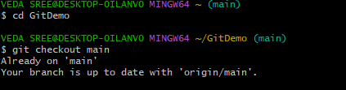

- List out all the available branches.

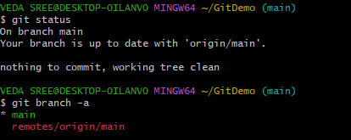

- Pull the remote git repository to the master
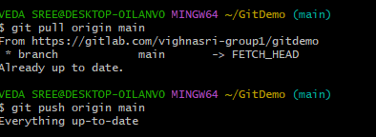
- Push the changes, which are pending from “Git-T03-HOL_002” to the remote repository.

